UNIT-5
TOPIC-1:- Cluster Analysis: Clustering Techniques & Different Types of Clusters
Definition
Cluster Analysis is an unsupervised learning technique used to group similar data objects into clusters such that:
- Objects within a cluster are highly similar
- Objects between clusters are highly dissimilar
It is widely used in data mining, pattern recognition, and machine learning.
Clustering Techniques
1. Partitioning Methods
Divide data into k clusters.
Example:
- K-means
- K-medoids
2. Hierarchical Methods
Create a tree-like structure of clusters.
Types:
- Agglomerative (bottom-up)
- Divisive (top-down)
3. Density-Based Methods
Clusters are formed based on dense regions of data points.
Example:
- DBSCAN
4. Grid-Based Methods
Data space divided into grid cells.
Example:
- STING
- CLIQUE
Types of Clusters
1. Well-Separated Clusters
Points in cluster are closer to each other than to other clusters.
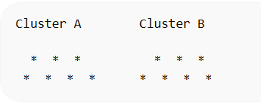
2. Density-Based Clusters
Clusters defined by high-density regions.
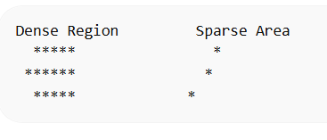
3. Contiguous Clusters
Objects are connected through nearest neighbor relationships.
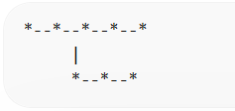
4. Conceptual Clusters
Clusters formed based on shared characteristics.
Example:
- Customers grouped by purchasing behavior.

TOPIC-2:- K-Means: The Basic K-Means Algorithm
Definition
K-Means is a partitioning clustering algorithm that divides dataset into k clusters.
Each cluster is represented by its centroid (mean point).
K-Means Algorithm Steps
- Choose number of clusters k
- Randomly select k centroids
- Assign each data point to nearest centroid
- Recalculate centroids
- Repeat until clusters stabilize
K-Means Clustering Diagram
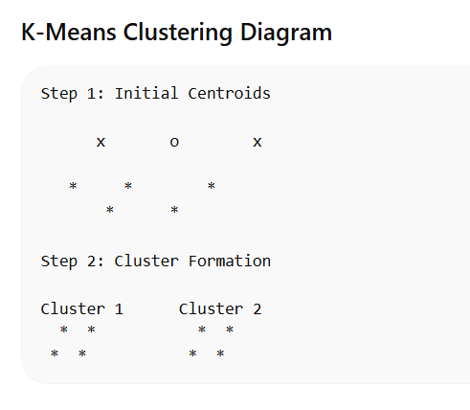
TOPIC-3:- K-Means Additional Issues
Although K-means is simple, it has several issues.
1. Selecting Value of K
Choosing wrong k leads to poor clustering.
Solution:
- Elbow method
2. Sensitivity to Initial Centroids
Different initial centroids → different results.
3. Outliers Problem
Outliers can distort cluster centers.
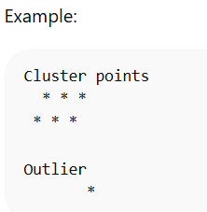
4. Works Only for Spherical Clusters
K-means assumes clusters are circular in shape
TOPIC-4:- Bisecting K-Means
Definition
Bisecting K-means is a hybrid clustering method combining hierarchical and K-means techniques.
It repeatedly splits clusters into two clusters.
Algorithm Steps
- Start with all objects in one cluster
- Select a cluster to split
- Apply K-means with k = 2
- Repeat until desired clusters formed
Bisecting K-Means Diagram
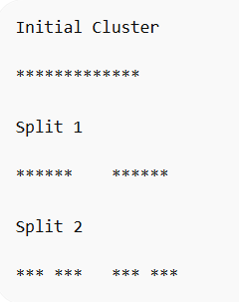
Advantages
- More accurate than basic K-means
- Produces better cluster quality

TOPIC-5:- Agglomerative Hierarchical Clustering
Definition
Agglomerative clustering is a bottom-up hierarchical clustering technique.
Each data point starts as a separate cluster, then clusters merge step by step.
Basic Algorithm
- Start with n clusters (each object)
- Compute similarity between clusters
- Merge closest clusters
- Repeat until one cluster remains
Hierarchical Clustering Tree (Dendrogram)
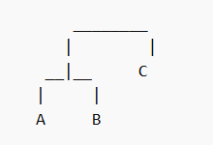
This diagram is called a dendrogram.
Linkage Methods
Single Linkage
Minimum distance between clusters
Complete Linkage
Maximum distance between clusters
Average Linkage
Average distance between clusters
TOPIC-6:- DBSCAN: Density-Based Approach
Definition
DBSCAN (Density-Based Spatial Clustering of Applications with Noise) groups together points that are closely packed together.
It identifies:
- Dense clusters
- Noise (outliers)
Key Concepts
1. Epsilon (ε)
Radius around a point.
2. MinPts
Minimum number of points required to form a cluster.
Types of Points
Core Point
Has sufficient neighbors.
Border Point
Near a cluster but not dense.
Noise Point
Outlier.
DBSCAN Concept Diagram
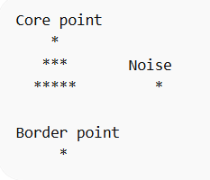
TOPIC-7:- DBSCAN Algorithm, Strengths and Weaknesses
DBSCAN Algorithm Steps
- Select an unvisited point
- Find neighbors within ε radius
- If neighbors ≥ MinPts → form cluster
- Expand cluster
- Mark remaining points as noise
DBSCAN Algorithm Flow
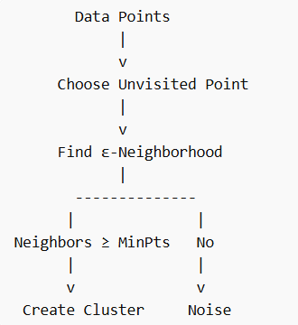
Strengths
✔ Detects arbitrary shaped clusters
✔ Handles noise effectively
✔ No need to specify number of clusters
Weaknesses
✖ Difficult to select parameters
✖ Poor performance with varying densities
TOPIC-8:- Mining Rich Data Types: Mining Text Data
Definition
Text Mining extracts useful knowledge from unstructured text data.
Examples:
- Emails
- Web pages
- Documents
- Social media posts
Text Mining Process
- Text collection
- Preprocessing
- Feature extraction
- Pattern discovery
- Knowledge extraction
Text Mining Process Diagram
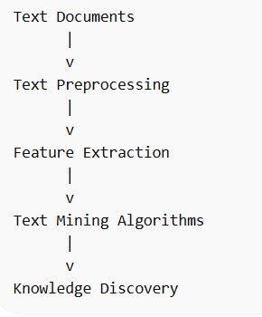
TOPIC-9:- Spatial-Temporal Data
Definition
Spatial-temporal data contains location and time information.
Examples:
- Weather data
- GPS tracking
- Traffic monitoring

Example Dataset
Location | Time | Temperature
City A | 10 AM | 32°C
City B | 11 AM | 30°C
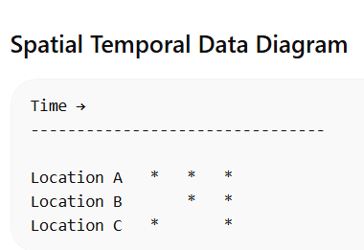
This shows data changing across time and space.

TOPIC-10:- Graph and Networks
Definition
A graph represents relationships between objects.
Graph consists of:
- Nodes (Vertices)
- Edges (Links)
Graph Structure
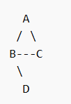
Applications
- Social networks
- Web page links
- Communication networks
Types of Graphs
Directed Graph
A → B → C
Undirected Graph
A — B — C
Network Mining
Network mining analyzes:
- Community detection
- Link prediction
- Influence analysis
